FUNCTION-BASED (F-B)
THINKING
Behavior Science
Tier 2 behavior interventions and supports is grounded in the science of applied behavior analysis, which is the design, implementation and evaluation of environmental modifications to produce socially significant improvement in behavior.

Knowledge of the “ABC’s” of behavior is a central focus in understanding applied behavioral analysis.
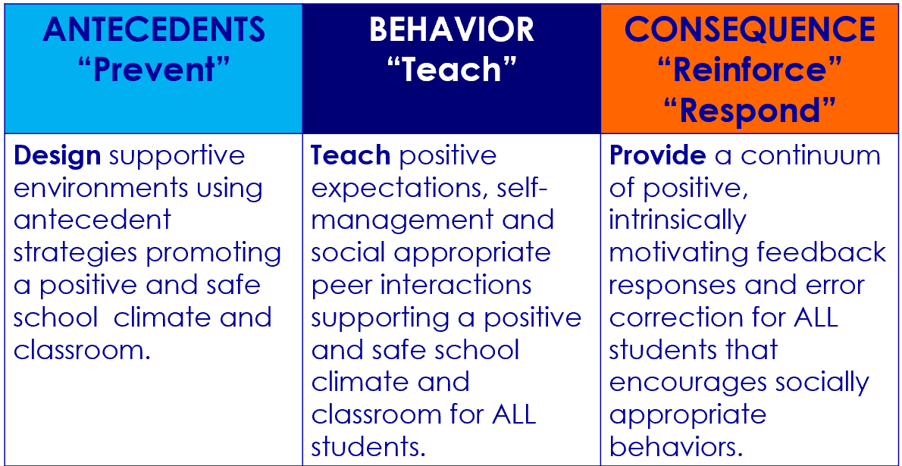
“ABC” is an acronym for:
ANTECEDENTS
are cues, prompts, signals, questions, commands, & reactions happening right before the behavior occurs; they are the happenings occurring before the behavior, setting the stage or triggering the behavior.
BEHAVIOR
is the observable, measurable and clearly defined actions or reactions of the individual to the environment or antecedent.
CONSEQUENCES
are the outcome or feedback occurring immediately following the behavior; positive corrective feedback helps students learn and use appropriate behavior in the future.

Behavioral Framework  - Behavior support is about the design of effective environments.  - Taking the time to understand why a student continues to engage in problem behavior in a specific routine is important.  - Without understanding the ABC’s of behavior, an intervention plan is as likely to make a problem worse as to make it better. | What we know for sure about behavior  - At-risk students persevere when they feel supported and successful.  - Punishment does not work; you can’t take away enough.  - Punishment destroys motivation to cooperate.  - Specific praise works.  - Teach and practice the behaviors you want. | Function-based (F-B) Thinking  - A systematic method to understand and address less complex behavioral issues  - A helpful tool in gaining AND utilizing information  What is the behavior?  When and where does it occur?  What are the reinforcers/consequences?  What is the motivation for the behavior?  What replacement behaviors can be taught, practiced and reinforced?

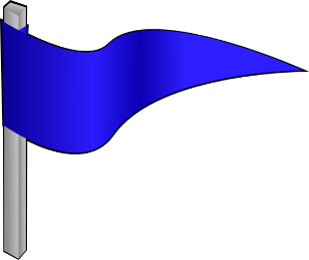
HWY ABC’s of Behavior
#1
PACK YOUR BAGS
Instructions: On your luggage card complete the sentence starters. Give directions for Stand Up, Hand Up, Pair Up: with your partner share what’s on your luggage, on the signal change places and report out what you heard your partner say (practice active listening and turn taking)
My traveling strengths are…

What motivates me to do something I like is…

What motivates me to do something I don’t like is…

What motivates me to do something new I have never done before is …
BS-2

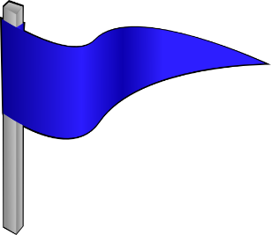
HWY ABC’s of Behavior
#2
ROAD SIGNS
Instructions: Individually complete the Synectic (metaphor), share at your table, popcorn a few answers from the group or have a team select one from their table to share out with the whole group

Understanding problem behavior is like…because….

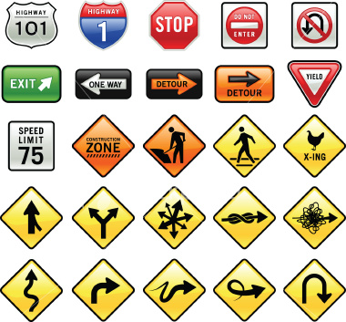

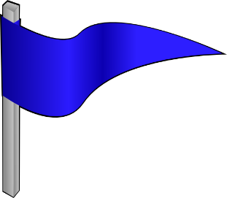
HWY ABC’s of Behavior
#3
THE “WHAT”
Always start with the “What”
Define behavior that is:
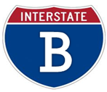
- OBSERVABLE
- MEASUREABLE
- CLEARLY DEFINED, where a person unfamiliar with the student could recognize the behavior without any doubts

Behavior is the observable, measurable and clearly defined actions or reactions of the individual to the environment or antecedent. When working with behavior change, focus on one behavior at a time. Start with the behavior of highest need, rate and/or intensity. Taking care of that behavior may eliminate many other little behaviors. It is important to remember when describing behavior, we are using words which are specific, observable and measurable to the behavior and not the person.
Instructions: Complete Chart
Defining Problem Behavior
NONEXAMPLES | EXAMPLES

Instructions:
Do not go back to your school and tell people who say “bad behavior” or “problem behavior” they are wrong. Just repeat back to them, “So, the behavior you would like to target for change is _______________ (label the behavior in measurable and observable terms).” What will happen is, the staff will pick up your words and start to use them without even realizing you have changed their mindset.”
-Dr. Laura RIffel, www.behaviordoctor.org

HWY ABC’s of Behavior
#4
THE “WHERE” & “WHEN”
Antecedents are cues, prompts, signals, questions, commands, reactions which happen right before the behavior occurs; they are setting the stage or triggering the behavior.

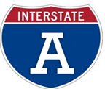
Where (routine)
- ID the routine (where) behavior occurs
When (Antecedent/Trigger)
- ID the event, action, or object occurring right before the misbehavior (when)

During lunch when told to shut up by a peer, Ben hits the student
During Language Arts, when asked to read aloud in class, Teresa gets up and makes jokes.
During chemistry lab when corrected Jessie starts crying.

Traditionally, approaches to discipline have been punitive in nature, where the emphasis is on negative consequences or what is done following the behavior to punish or suppress the undesired behavior. PBIS focuses heavily on prevention practices or antecedents; in other words, the things we can do to set students up to behave in socially appropriate ways.

- Clarify expectations so all students understand what they are expected to do.
- Teach those expectations to students in an ongoing way so as to insure students know how to behave successfully across multiple settings
- Effectively respond to behavior – appropriate or inappropriate – to shape the behavior you seek.

Instructions: Create a simple list of common antecedents to undesired behaviors.
1.
2.
3.
4.
5.
6.
7.
8.
9.
10.

HWY ABC’s of Behavior
#5
THE “CONSEQUENCE”/THE “WHY”
The two-step rule for determining the consequence of the behavior:

Step 1
Determine the consequence or outcome of what happened right after the behavior.
Step 2
Determine the function (or purpose) the behavior is serving for the student
- “What is the pay-off?”
- Understand from the students’ perspective

Consequences are the outcomes or feedback occurring immediately following the behavior; positive corrective feedback helps students learn and use appropriate behavior in the future. Punishers or negative consequences may stop the undesired behavior for the moment, only to return and require further action. Punishers and negative consequence often become “reinforcers.” The basic definition of a “reinforcer” is anything driving the behavior up or serves to reinforce the undesired behavior. Typically, people think of punishment when they hear the word consequence. When we are thinking of consequences in function of behavior terms, we are thinking about what is specifically maintaining the behavior. We need to ask ourselves “what the child is trying to get” or “what they are trying to avoid” by having the behavior; what purpose or function does the behavior serve?

Instructions: Fill in the blanks.

To Obtain/_______________:  - Peer Attention  - Adult A_____________  - Desired Activity  - Desired Object/Items  - __________________ |  | To _______________/Escape  - Difficult task  - Boring ____________  - Easy task  - Physical ___________  - Non-preferred activity  - Peer ______________  - Adult (reprimands, attention)  - Sensory

HWY ABC’s of Behavior
#6
“HYPOTHESIS”/ “SUMMARY STATEMENT”
Putting It All Together
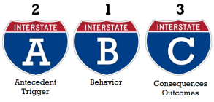

The hypothesis or summary statement integrates our understanding of the problem behaviors within a specific routine. Strategies based on the hypothesis statement will be used to…

prevent the problem behavior

teach an alternative behavior

increase desired alternative behavior

decrease the problem behavior

“Tracy” Summary Statement

Where(routine)____________________________________________________________________

When_____________________________________________________________________________

Tracy does________________________________________________________________________

As a result, ________________________________________________________________________

Therefore__________________________________________________________________________

“Frustrated Fred” Summary Statement

Where(routine)_____________________________________________________________________

When______________________________________________________________________________

Frustrated Fred does________________________________________________________________

As a result, _________________________________________________________________________

Therefore_____________________________________________________________________

